**LECTURE 01**

* Intro to bootstrap nothing much to note about

**LECTURE 02 (Installing Bootstrap)**

1st method to add bootstrap

* To add bootstrap to your website, go to getbootstrap.com
* Add the following link to your website
* <link href="https://cdn.jsdelivr.net/npm/bootstrap@5.3.0-alpha1/dist/css/bootstrap.min.css" rel="stylesheet" integrity="sha384-GLhlTQ8iRABdZLl6O3oVMWSktQOp6b7In1Zl3/Jr59b6EGGoI1aFkw7cmDA6j6gD" crossorigin="anonymous">
* Now if your user doesn’t have bootstrap files cached on your browser it will download the bootstrap files from the link provided in the link tag.
* “cdn” is a content delivery network spread across the whole world, basically cdn allows bootstrap files to be fetch relatively quickly from various places.
* Normally most browsers already have a bootstrap files cached locally since a lot of websites use bootstrap to it’s a pretty good chance that your user will already have bootstrap files on his computer.

2nd method to add bootstrap

* If you want to add some functionalities like drop down menus etc that is gonna need more than simple html css, bootstrap is gonna need some javascript for that. To add bootstrap this way you can copy and paste the basic html template from the bootstrap website and start working onwards from there.

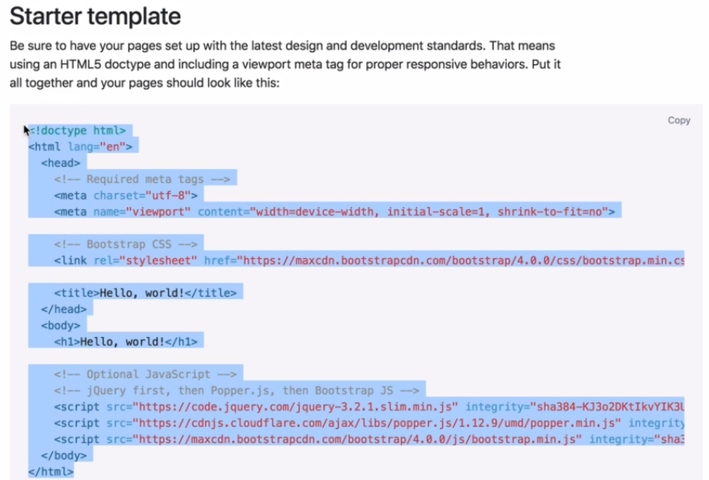

3rd method of adding bootstrap

* You can download the bootstrap source files and add them into your websites via a relative URL. A downside of doing this is that your user’s browser won’t be able to take advantage of caching if you decide to go down this route. This route may lead to a bit of latency.

**LECTURE 03 (Webdesigning 101 – Wireframing)**

* The first step of creating a website is making the wire frame of the website 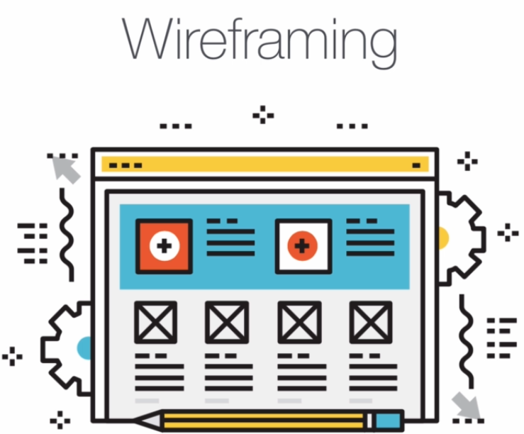
* It is supposed to be a low-fidelity and quick process that outline the basic structure of your website.

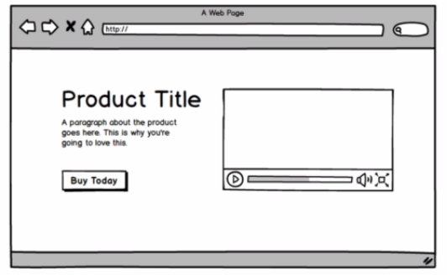

* The opposite of a wire frame is a mockup, which is supposed to be a high fidelity representation of your website.
* The basic workflow for creating a website is first looking at other similar websites at forums like [www.awwwards.com](http://www.awwwards.com) or [www.ui-patterns.com](http://www.ui-patterns.com) to get a look at ui components and the problems those components are trying to solve.
* Next step is to make a simple sketched wire frame that’ll decide where everything will stand.
* [Optional] The next step is to create a mockup by using something like photoshop or illustrator
* [www.dribble.com](http://www.dribble.com) is a really great site for finding inspiration for websites.
* You can get many wireframes from [www.sneakpeekit.com](http://www.sneakpeekit.com)

**LECTURE 04 (The bootstrap navigation bar)**

* Nothing much to note down in this section, she taught how to create a navbar using bootstrap classes.
* Bootstrap has the following colors which you can use with various classes.

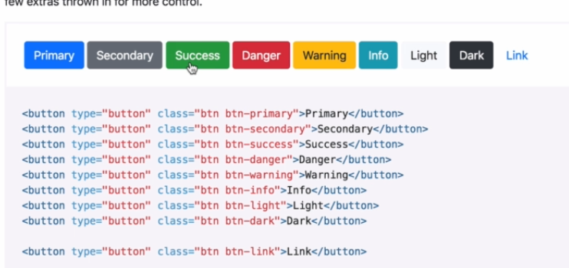

* For eg: Primary means blue, secondary means gray, success means green, danger means read and yellow means warning and so on.
* “ml-auto” or margin-left-auto pushes the element towards the right by putting as much of left margin as it needs to so the element may look like this



**LECTURE 05**

* 1 min intro video, nothing to be talked about.

**LECTURE 07**

* Setting up a basic project.

**LECTURE 08 (Grid system using bootstrap)**

* In bootstrap a row has 12 columns, so if you want to create a column that cover half page (or 6 rows) then you will have to add the class=”cols-6” to your div.
* Adding screenshot of a code snippet along with output to better explain it.

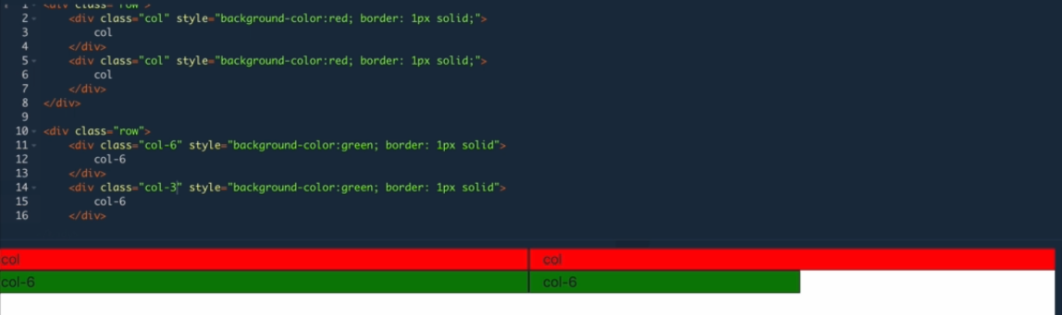

* But these columns are not responsive i.e. they don’t change their position on different sized devices.
* For responsiveness, you will have to use the class=”col-md-6”, now what this means is that for devices of medium sizes and above (tablets and bigger) this column will occupy the half part of screen, but for devices what are smaller i.e. smartphones etc it will occupy the full row of screen.
* Code snippet below attached for better understanding.

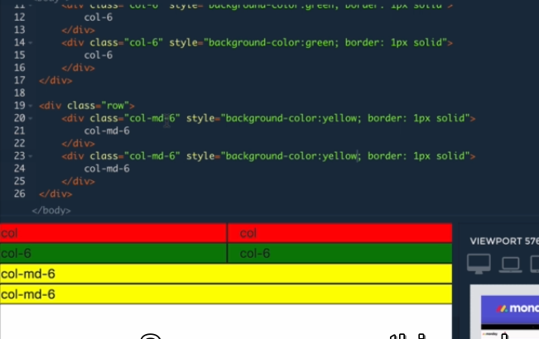

* Now if you want to make your website furthermore responsive like on computer it should have 4 boxes, on tablets it should have 3 and on mobile phones it should have 2 then you can do so by adding the following classes to your divs

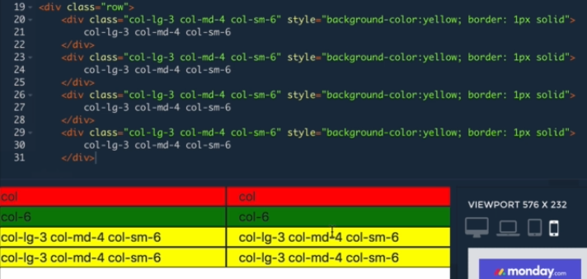

* Here col-lg-3 class tells that on full width/computer screens every box should have 4 columns (keep in mind that in bootstrap every row has 12 cols so basically we will have 4 cols in each row).
* Now on medium sized screens we have the rule col-md-4 that says that each items width on medium tablet/sized screen will be 4 i.e. each row will have 3 cols
* Finally we have added the class col-sm-6 which will have 2 cols per row on small devices like mobile phones etc.

**LECTURE 10**

* Implementing what we’ve learned so far to create a little project for this module.

**LECTURE 12 (Bootstrap containers)**

* Containers allow us to hold cols and rows in orderly fashion.
* There are 2 kinds of containers in bootstrap, container and container-fluid.
* “container” centers the contents of itself and also allows responsiveness for various screen sizes, the difference is that with this kind of containers the responsiveness and the changing of size of window feels like a “jerk” change in the composition of the container.
* While “container-fluid” also holds the contents of itself and provides responsiveness but it also while changing the dimensions of its components to provide responsiveness it does so with fluidity. There is no “jerk” response when dimensions of the component changes.

**LECTURE 14**

* Made a demo website using the things I’ve learnt thus far.

**LECTURE 16**

* Made a demo website using the things I’ve learnt thus far.